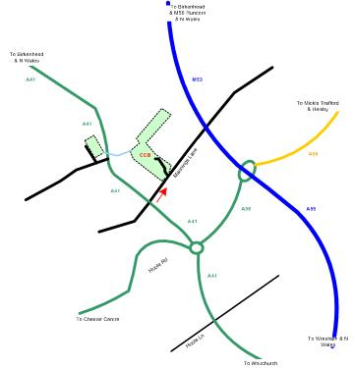

Venue; Cheshire County Officers Outdoor Sports Grounds,
Mannings Lane, Upton, Chester, CH2 4EU

Further copies of this entry form can be downloaded from the Cheshire County Bowmen Website (www.ccbarchery.co.uk) or can be photocopied.

Northern Counties Archery Society

Cheshire County Bowmen
37th Annual shot

CHESTER

Double WA 720 50m
(For Compounds and Barebows)
Double WA 720 70m
(for recurves and longbows)
and 60m (for Masters and cadets)

World Record Status.
6th July 2025

When you enter competitions the following information may be collected and shared with tournament organisers, other competitors, and AGB. Target lists and results containing the following information may be published and placed on the web site: First Name, Surname, Gender, Bow style, Age category, Club , County , Region , Round (unless defined by age), Disabled (Y/N), Disability info. . The tournament organiser may also collect Email, Address and Phone number but this will not be published or shared ..

Please be advised that we cannot delay the shoot by spending extra time during the distances looking for arrows made of all carbon . Extra time will be spent searching when there is time at the end of the session
Cheshire County Bowmen

Chester WA 720 6th July 2025

Entry Form. Fees £15.00 per archer
Mr.  Mrs.  Miss | Name | Club | LH or RH | AGB  No. | Lady, Gent , MastrCadet | Extra information eg need to stay on line | Recurve/  Compound  Longbow/ Barebow

FEES Pay by BACS to Cheshire County Bowmen
Account Name: Cheshire County Bowmen
Account Number: 56564562
Sort Code: 01-07-02
Label it with your name and WA720

Entries via email to pandfgl@ntlworld.com
OR Cheques made payable to Cheshire County Bowmen. Postal entries to F. G. Lloyd 14 Cedardale Drive, Ellesmere Port, Cheshire CH66 2UW

Name, address and telephone number of contact:

email address _______________________________________________

emergency tel. contact number __________________________________

ROUND ; Double WA 720 70m, 60m and 50m

FEE £15

DATE ; 6th July 2025

TIMINGS
8.45am Equipment inspection
9.15 am - 9.45 am practice on the shooting range
10.00 am Shooting commences

VENUE ; Cheshire County Officers Outdoor Sports Grounds,
Mannings Lane, Upton, Chester, CH2 4EU .

SHOOTING ; Arrows will be shot in ends of 6
Shooting is on foam bosses

CLOSING DATE. 20th June 2025

Please enclose two large s.a.e. if you wish to receive target list and
result sheets otherwise these will be sent to you by email.

Lady Paramount MrsC Bladen
Chairman of judges Mr I.Ashworth
Judges Mrs B. Timperley, Mr S. Gibson Mr J Edwards

Archers must comply with AGB. Dress Rules.

Record Status shoots will be liable for drug testing and competitors
approached to give samples must comply, if they refuse that refusal will
be treated as a positive result.
Juniors must have the signature of a Parent or Guardian on their entry
form giving their consent to a drug test if requested.

